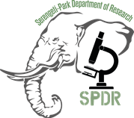
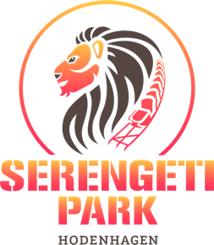

SERENGETI-PARK DEPARTMENT OF RESEARCH (SPDR)
BIOLOGICAL SAMPLES REQUEST FORM

In order to comply with the research strategies of the European Association of Zoos and Aquaria (https://www.eaza.net/), we require justification of any samples taken from live animals at the Serengeti-Park Hodenhagen GmbH. Details should be provided about the benefits to the individual animal, its species group or environment. Samples obtained remain the property of the Serengeti-Park Hodenhagen GmbH and may not be used for any other purpose, including commercial purposes, other than that described in this form. If the request is approved, samples can only be supplied opportunistically and can only be a small amount of that taken for diagnostic purposes. Sample collection must be non-invasive. For more information, please refer to the Research Policy of the Serengeti-Park Department of Research (SPDR).

Contact information:
Name:
Institution address:
Phone number:
Email address:

Does the research have the support of an EEP or group such as the EAZA Research Committee? Yes No
Yes
Yes
If yes, please provide evidence or letter of support (in this case, fee is waived for cost of sending requested samples):

Has ethical approval been obtained from an Institutional Ethical Review Process? Yes No
Yes
Yes
If yes, please provide details, including date and approval number:

Has the proper CITES permit been granted for the export of species’ specimen? Yes No N/A
Yes
Yes
Yes
If yes, please provide details, including date:

Project Outline:
Title of project:
Rationale (max. 250 words):
-include project justification, objectives and potential impact of the research
What type of samples are you requesting and from which species?
(include common and scientific name of the species)
Please detail sample collection and handling protocols:
- Number of samples
- Volume of sample(s)
- Collection and storage procedures
- Equipment required for collection
-Handling and transport procedures
What date do you need the samples by?
What is your shipping address?
How will you cover the costs of the project?
Researchers are required to cover any costs generated by their approved projects, including supply of materials and/or organization and transport of samples or equipment.
Will this study contribute towards an academic qualification or degree?
If yes, please specify.

Project impact:
How will this project benefit the individual, group or species from which samples are taken?
How will the results of this project be disseminated? Conference presentations, peer-reviewed journal publications, thesis dissertation, etc.
Expected date of progress report submission to the wild animal Park review team of the Serengeti-Park Hodenhagen GmbH

Acceptance of terms and conditions of Serengeti-Park Department of Research (SPDR) Research Policy:
If the study will contribute to an academic qualification or degree, this form must be signed by the student and the academic supervisor(s).

Please note that upon completing, signing and registering this form, researchers are bound by the terms and agreement of the SPDR’s Research Policy. Furthermore, researchers agree to provide the SPDR with an electronic and hardcopy of the project report. SPDR is to be immediately informed if results reveal important data that would have a direct impact on the welfare and husbandry of the animals sampled.

Name | Title | Signature | Date
- Please send an electronic copy, with or without signatures to i.azogu@serengeti-park.de AND/OR
- Please mail a signed hardcopy to the following address:
Dr. Idu Azogu-Sepe, Serengeti-Park Department of Research, Serengeti Park Hodenhagen GmbH, AM SafariPark 1, 29693, Hodenhagen, Germany.

